1. Indoor: Propellers not rotating

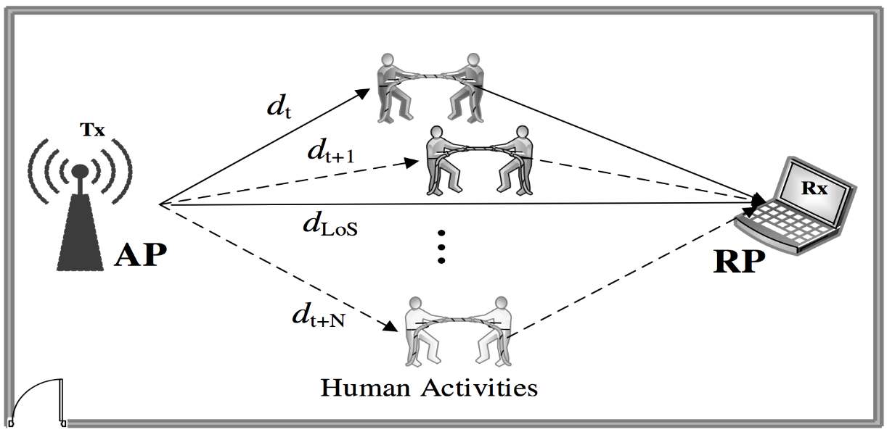



2. Indoor: Propellers rotating



1. Drone fixed and rotating with different speed
2. low speed
3. medium speed
4. fast speed
5. Body shifting
6. forward/backward/left/right
7. rotating horizontally

3. Outdoor: different distances between UAV and AP

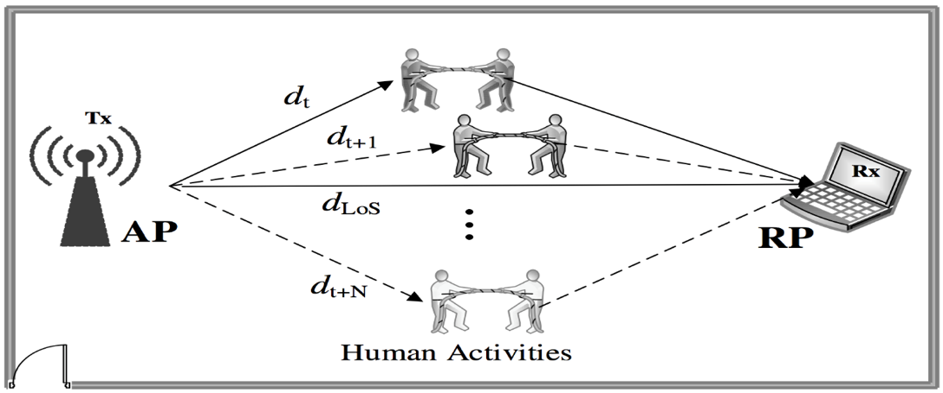

d



4. Outdoor: different distances between AP and window



 

d